Order Of Lenten Service

Opening Hymn: TLH 170

Reading: Lent I

The History of the Passion of our Lord

Sermon Hymn: TLH 142

Sermon Text: Mark 12:41-44

Two Mites

Prayer

Holy Communion

The Lord's Prayer

The Blessing

Closing Hymn: TLH 147

* * * * * * * * * * * * *

Bible Study: Lambs: Whistling Swan
Sheep: Proverbs 22:22-25

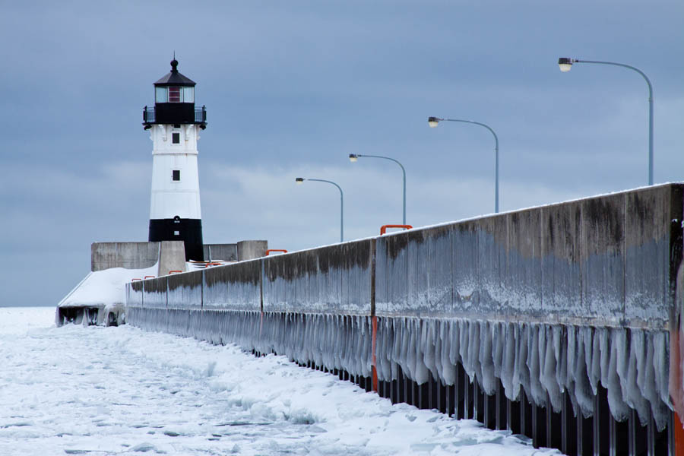

Canal Park, Duluth, MN

Water
Of
Life

23 February 2020

W A T E R O F L I F E

Independent Christian Church—Conservative Lutheran Doctrine

Worship Service: 9:30 a.m. Bible Study: 10:45 a.m.

Larry Cooper, Pastor E-Mail address:
111 N. Ridge Road lcooper@wateroflife.cc
Coon Valley, WI 54623 Web Site:
www.wateroflife.cc

* * * * * * * * * * * * * * * * * * * * * * * * * * *

Sermon Text: Mark 12:41-44

Two Mites

* * * * * * * * * * * * * * * * * * * * * * * * * * *

Mark 12:41 And Jesus sat over against the treasury, and beheld how the people cast money into the treasury: and many that were rich cast in much.
:42 And there came a certain poor widow, and she threw in two mites, which make a farthing.
:43 And he called unto him his disciples, and saith unto them, Verily I say unto you, That this poor widow hath cast more in, than all they which have cast into the treasury:
:44 For all they did cast in of their abundance; but she of her want did cast in all that she had, even all her living.

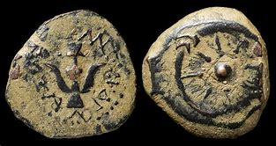

More Than They All

